Bandits dev diary

# Bandits come back

TODO : speak about the creation of this feature.

# Classical bandits

In the Vanilla, if you have no more money, some bandits (thieves, smugglers and highway robbers) can appear in your province. They can disappear when you will have new again money.  
It is a very poor feature.

We have changed the condition of apparition of the bandit.  
You can now have bandits when you manage badly your demesne (overthrow the demesne limit).  
They can disappear when you have money AND you respect the demesne limit.

We have also added another bandit group: the pirates for the coastal provinces.

But we have also do more.

All the additional content which will be presented after is optional. It can be enable/disable by a game rule.

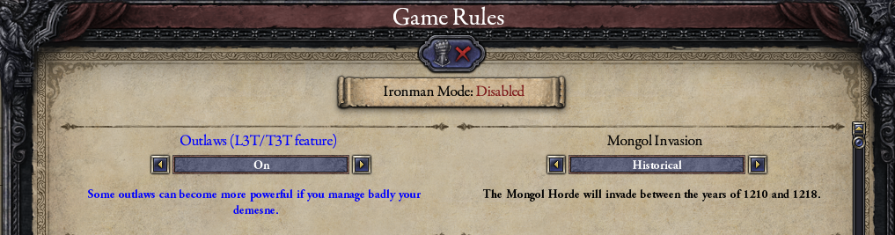

# More powerful bandits

If the bandits stay in your province after some time, they cause many problems and you heard people talk about them.

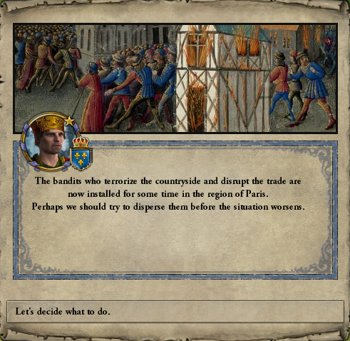

If you are not in war, you can convoke the Council (not related to Conclave DLC).

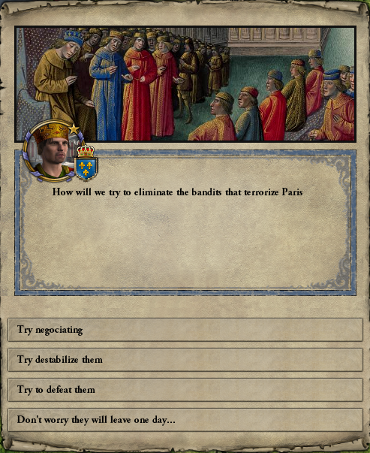

If your action is a success, the bandits leave your province but the province will need some time to be as productive as before the bandits.

If your action fails, the bandits will become more powerful.

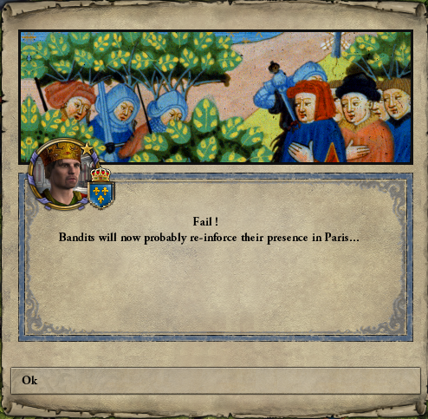

They will proliferate, it is a good thing for the province economy after some time.

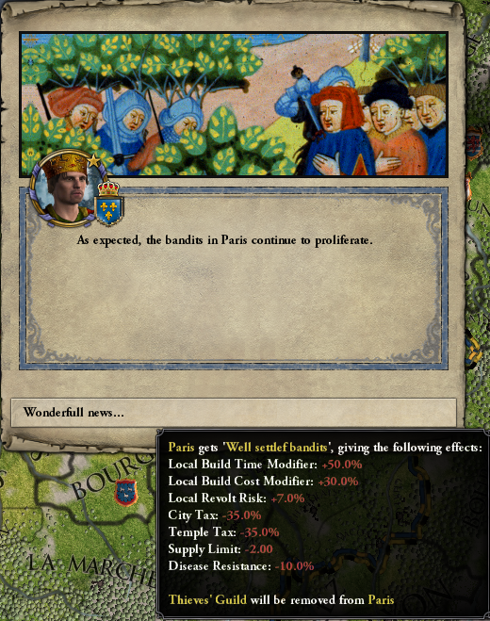

The bandits try to organize themselves.  
After some time, they can disappear or be fully settled with a leader.

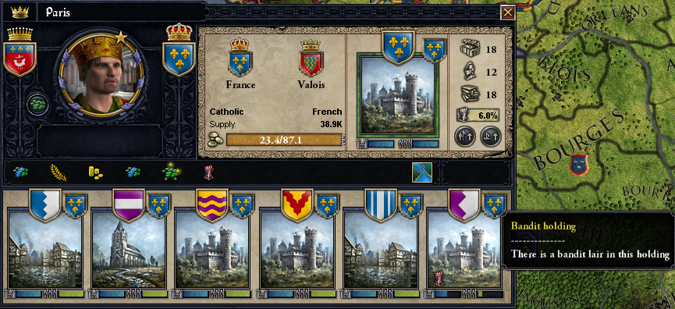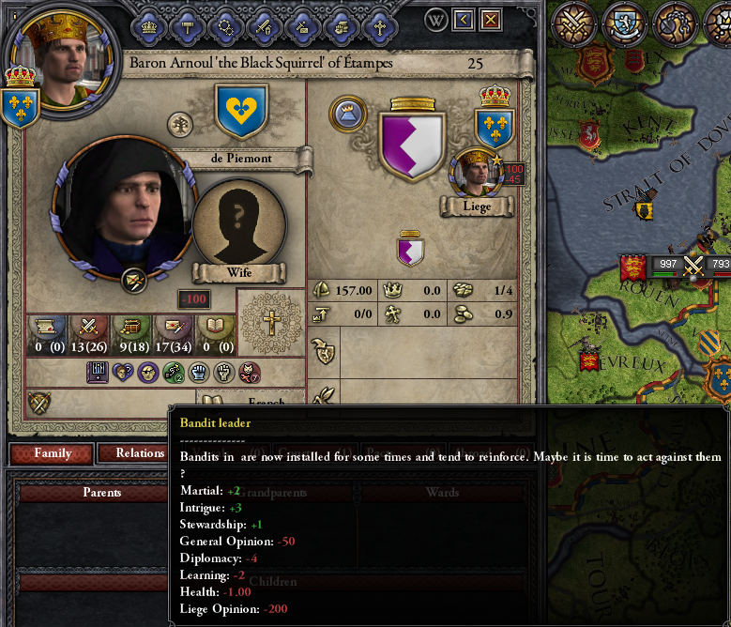

# The bandit life

Now our bandits are settled, they will cause other problems.

They can loot the holdings of the province.

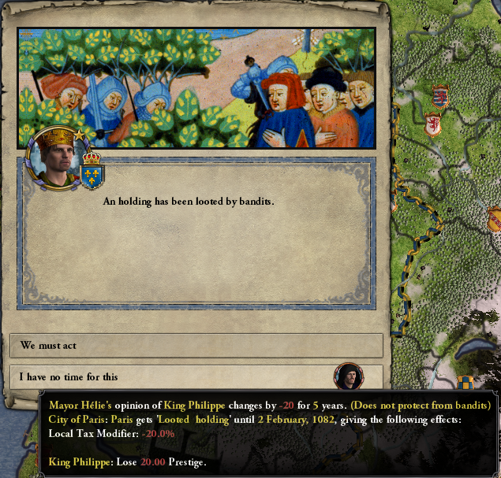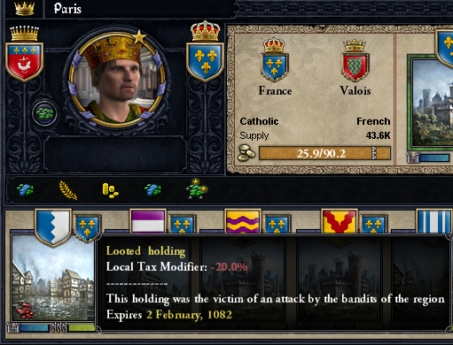

Like the bandit life is dangerous, the bandit leader can die.  
A bandit can become the new leader or the group can be disbanded.  
In that case the game say you that you inherit of the title (the game give you the title automatically when there is no successor, but you will not take benefit about it).

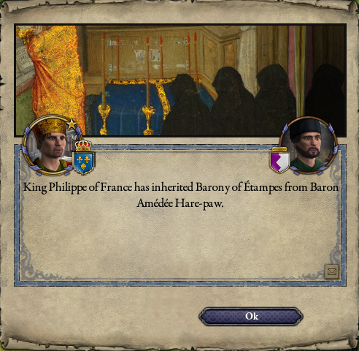

Like if you would have a success at the beginning with the council action, the province will be some difficulties to become as profitable as before the bandit settling.

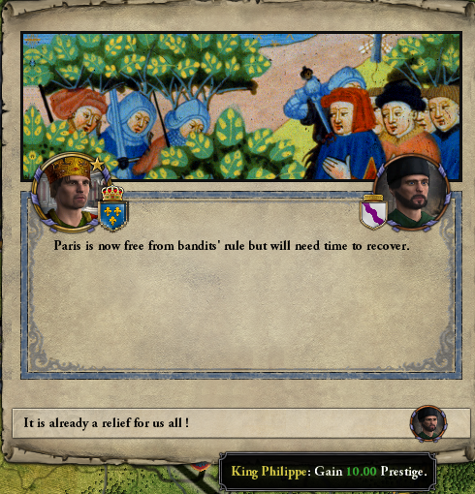

# What we want to do

* Add some actions to fight against the bandits. In that moment, the only one method to eliminate them is to kill their leader until there is no more one
* Add more flavor events